Steps for Project Setup:

Repository Location: <https://github.com/rahulhnikhare/totList>

(**Note: Its public repository I have made . Its havind 2 Zip files.

1.TodoList-master.zip => This is an UI project source code in Angular. Refer below steps for setup

2.sts-todoList.zip => This is backend code in Spring Boot )

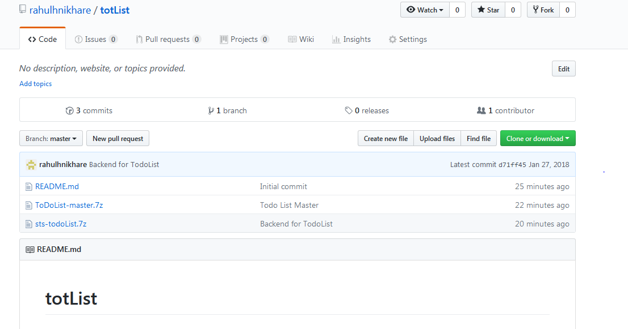

Angular 2/4 setup for UI.

Required Tool: IntelliJ

1. Create new project **“ ng new ToDoList-master**”

This will create new project as shown below

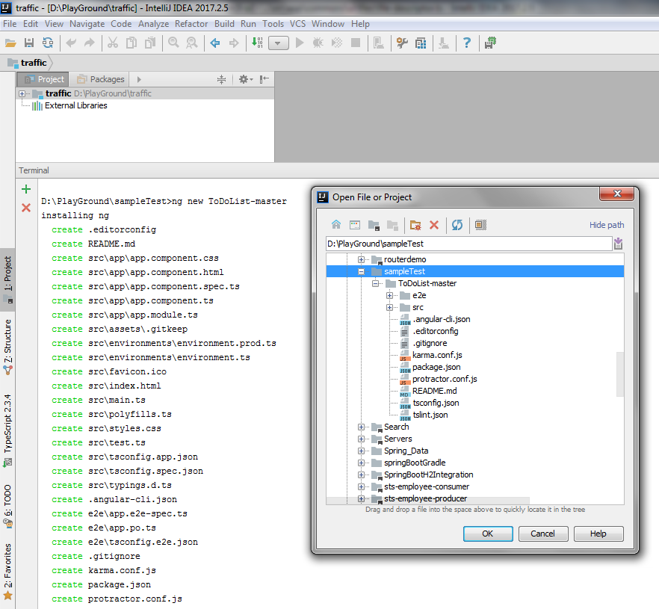

1. Extract TodoList-master.zip inside ToDoList-master folder created in step1
2. Open Terminal . Execute “**npm install**”
3. Execute “**ng serve** “
4. Go to [**http://localhost:4200**](http://localhost:4200)

Backend setup in Spring-Boot

**Tool Used:** Spring tool Suits (STS)

1. Create new workspace. Extract zip **sts-todoList.zip**  into it.
2. Import maven project in workspace
3. Right click on **POM.xml** file . Run as maven Install

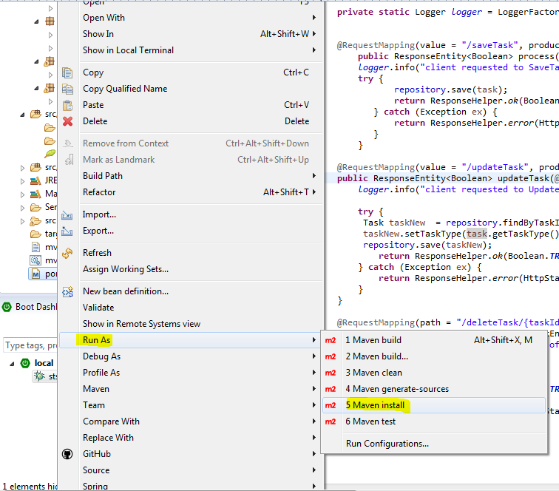

1. Right click on project and Maven Update project.

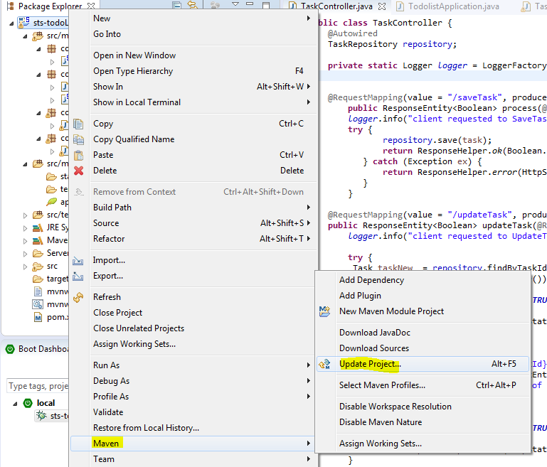

1. From BootDashBoard , start the application.

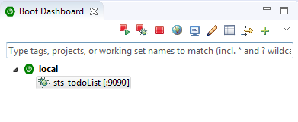

1. For H2 Database go to <http://localhost:9090/h2_console/>

**Username/Password : sa/sa**

